**ECEN204 Lab 2**

**Diode Characteristics: Report**

**Name: Niels Clayton Student Number: 300437590**

**Lab Partner: Nickolai Wolfe**

**1. Data sheet characteristics of the 1N4148 diode (Section 2)**

Tabulate the data sheet values that you have obtained for the various diode parameters in Section 2.

|  |  |
| --- | --- |
| **Characteristic** | **Value from datasheet** |
| The maximum constant (DC) forward current. | 300mA |
| The peak forward current surge lasting no more than 1 second. | 2A |
| The operating temperature range of the device. | -65 to +150 |
| The maximum power dissipation of the diode assuming a 25 oC environment. | 500mW |
| The reverse breakdown voltage with a reverse current of 5 μA. | 100V |
| The worst case recovery time of the diode | 4ns |

**2. Diode I-V curve and characteristics for Si diode (Section 3.1)**

* The resistance of the diode when on.

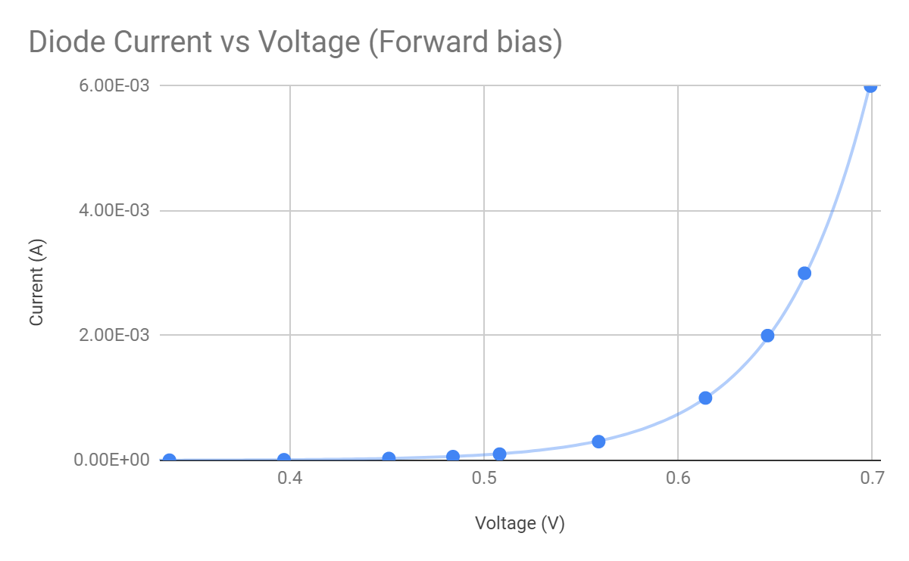

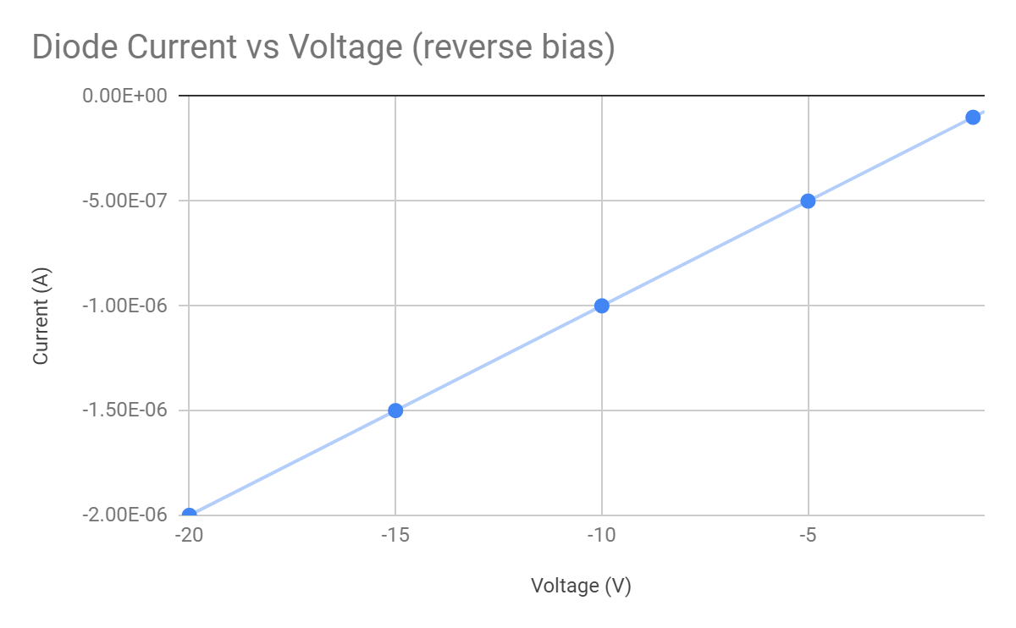

From these graphs it can be seen that the forward bias voltage drop across the diode tends towards 0.7V. Using this voltage, and the current through the diode, we can calculate that the resistance of the diode is ????, and the reverse bias current at -5V is -0.5uA.

**3. Diode I-V curve and characteristics for a LED (Section 3.2)**

* The resistance of the diode when on.

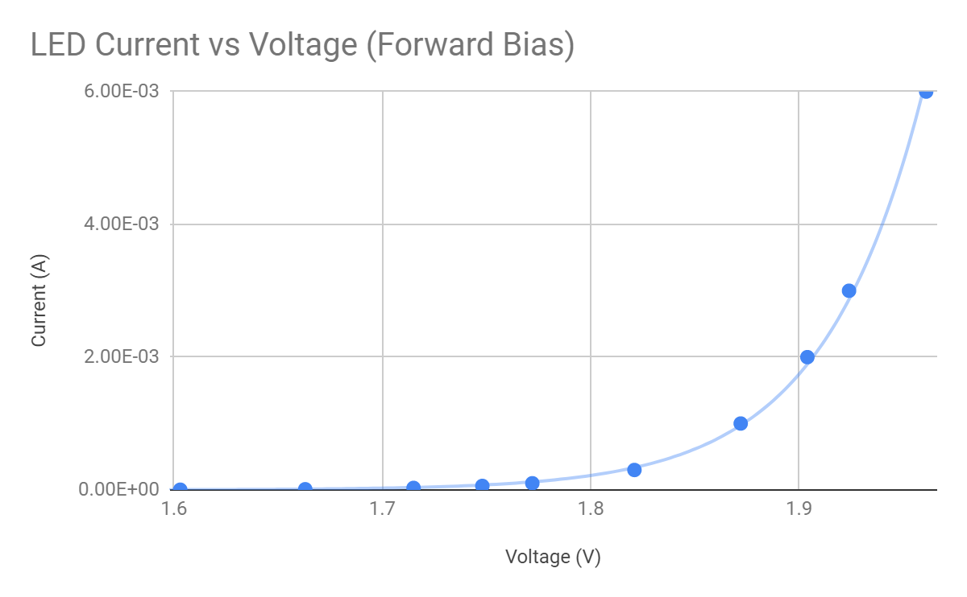 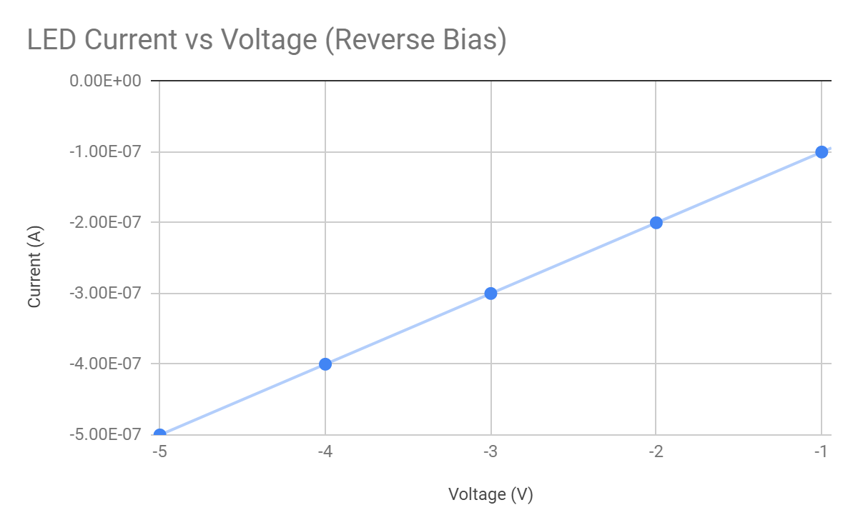

From these graphs it can be seen that the forward bias voltage drop across the LED tends towards 2V. Using this voltage, and the current through the diode, we can calculate that the resistance of the diode is ????, and the reverse bias current at -5V is -0.5uA.

**(b) What was the diode current when light emission was first observed? What colour is the light from the LED?**

We were observing a yellow LED, and the current at which we first observed light emissions was 60uA.

**(c) What would be a suitable value for the diode current in order to produce a suitable light level?**

To produce a suitable light level from the diode, the current should be between 3mA (first current level where the LED appeared bright) and 30mA (The general top rated current for a LED)

**(d) Compare the values of the voltage drop observed for diodes of different colours by exchanging results with other people in the lab who had a different colour LED.**

|  |  |
| --- | --- |
| **Diode Colour** | **VD ( V)** |
|  |  |
|  |  |
|  |  |

**(e) Why would these diodes show different colours in the output spectrum?**

The energy of the photons produced by an LED corresponds to the band-gap energy of the LED. The greater the band-gap energy, the higher the energy of the photon. Photons with higher energy will tend to look blue/purple, while photons with lower energies will be red/orange.

**4. The diode load line (Section 3.3)**

(a) Show the graph of your load line.

(b) Use this load line graph to determine the current through the diode and the voltage drop over the diode at the operating point of the circuit. Compare to the measured values from Section 3.1.

(c) The load line above was constructed using your experimentally determined diode curve. What would you do if this measured I-V data was not available ? Hint: How would you model your diode behaviour so that you can obtain a best estimate of circuit parameters (ID, VD) using ?

(d) Use this method you suggested in (c) above and sketch an approximate load line (no real I-V data available) and again calculate ID and VD. How much do these values differ from the values obtained using the actual diode curve in (a) and (b) ?

**4. Additional Questions**

**4.1 Temperature dependence of diode behaviour**

You repeat your measurements of the diode I-V characteristics, but you also perform these measurements with the diode immersed in liquid nitrogen (-196 oC) and in hot water (90 oC). The data from these measurements are shown in the table below.

|  |  |  |  |  |  |  |  |  |  |
| --- | --- | --- | --- | --- | --- | --- | --- | --- | --- |
|  |  |  |  |  |  |  |  |  |  |
|  | **Reverse Bias** | |  |  |  |  |  |  |  |
|  | **T=293 K** |  |  | **T=383 K** |  |  | **T=77 K** |  |  |
|  | **Voltage** | **I (uA)** |  | **Voltage** | **I (uA)** |  | **Voltage** | **I (uA)** |  |
|  | -9.8 | -1.0 |  | -10 | -0.9 |  | -10.06 | -2.6 |  |
|  | -7.98 | -0.8 |  | -7.99 | -0.7 |  | -8.5 | -2.3 |  |
|  | -7.24 | -0.7 |  | -7.3 | -0.6 |  | -7.3 | -2.0 |  |
|  | -5.08 | -0.5 |  | -5.9 | -0.5 |  | -5.02 | -1.5 |  |
|  | -3.056 | -0.3 |  | -3.6 | -0.3 |  | -3.32 | -1.1 |  |
|  | -1.969 | -0.2 |  | -2.43 | -0.2 |  | -2.05 | -0.8 |  |
|  | -0.325 | -0.1 |  | -0.85 | -0.1 |  | -1.02 | -0.5 |  |
|  | 0 | 0.0 |  | 0 | 0.0 |  | 0 | 0.0 |  |
|  |  |  |  |  |  |  |  |  |  |
|  | **Forward Bias** | |  |  |  |  |  |  |  |
|  | **T=293 K** |  |  | **T=383 K** |  |  | **T=77 K** |  |  |
|  | **Voltage** | **I (mA)** |  | **Voltage** | **I (mA)** |  | **Voltage** | **I (mA)** |  |
|  | 0 | 0.00E+00 |  | 0 | 0.00E+00 |  | 0 | 0 |  |
|  | 0.261 | 5.00E-04 |  | 0.121 | 2.70E-03 |  | 0.435 | 1.00E-04 |  |
|  | 0.363 | 3.70E-03 |  | 0.207 | 1.14E-02 |  | 0.726 | 1.00E-04 |  |
|  | 0.404 | 8.60E-03 |  | 0.27 | 3.19E-02 |  | 0.966 | 1.20E-03 |  |
|  | 0.45 | 2.29E-02 |  | 0.302 | 5.35E-02 |  | 0.989 | 6.60E-03 |  |
|  | 0.501 | 6.69E-02 |  | 0.415 | 3.51E-01 |  | 1 | 1.54E-02 |  |
|  | 0.533 | 1.33E-01 |  | 0.45 | 6.29E-01 |  | 1.016 | 5.78E-02 |  |
|  | 0.59 | 4.47E-01 |  | 0.48 | 1.05E+00 |  | 1.035 | 2.90E-01 |  |
|  | 0.606 | 6.26E-01 |  | 0.547 | 3.13E+00 |  | 1.041 | 4.82E-01 |  |
|  | 0.628 | 9.20E-01 |  | 0.57 | 4.49E+00 |  | 1.05 | 1.10E+00 |  |
|  | 0.652 | 1.41E+00 |  | 0.593 | 6.28E+00 |  | 1.066 | 2.90E+00 |  |
|  | 0.67 | 2.00E+00 |  | 0.629 | 1.04E+01 |  | 1.081 | 5.79E+00 |  |
|  | 0.685 | 3.13E+00 |  |  |  |  | 1.096 | 9.63E+00 |  |
|  | 0.696 | 3.91E+00 |  |  |  |  |  |  |  |
|  | 0.704 | 4.49E+00 |  |  |  |  |  |  |  |
|  | 0.712 | 5.22E+00 |  |  |  |  |  |  |  |
|  | 0.722 | 6.25E+00 |  |  |  |  |  |  |  |
|  | 0.735 | 7.81E+00 |  |  |  |  |  |  |  |
|  | 0.752 | 1.04E+01 |  |  |  |  |  |  |  |
|  |  |  |  |  |  |  |  |  |  |

(a) You must now compare the behaviour of this diode at the three different operating temperatures. Plot the three forward bias regions on one graph and the three reverse bias regions on another graph.

(b) From your forward bias graphs comment on the temperature behaviour of the forward bias voltage drop. Calculate an approximate value for the temperature variation of this voltage. Also discuss the observed trend in the forward bias voltage drop with temperature in more detail using your knowledge of semiconductors and the device physics of a p-n junction. **Hint:** Look the equation describing Vo (from your class notes) and see what the temperature dependence is of this equation.

(c) From your reverse bias graphs discuss the temperature behaviour of the reverse bias current. Can you suggest a reason for the temperature behaviour of this diode parameter ?

**4.2 Design of an LED circuit**

You must design a circuit for a light emitting diode. The circuit must be powered by a 3.3V power source and you need a current of at least 2 mA through the diode to ensure sufficient brightness. At the same time you would also like to limit the diode current to no more than 5 mA to limit your power consumption. Calculate a suitable value of the current limiting resistor for this circuit if it is given that the LED will have a forward voltage drop of 2.1 V over it. Show your reasoning and calculations.